**Digital Marketing**

***Week 1:***

**M -1Digital Marketing & its Significant*:***

* We noticed that there has been an increase of 1.8X since the initiation of the program, notifying us that there is a scope of growth.
* Currently, there are around 800 million users of mobile devices in India, and about 430 have access to the internet, which is a third of India’s population
* We believe Internet access will double in the next 10 years and we estimate that 915 million Indians will be on the Internet by 2026”.
* India has the second internet population in the world, after China.

***Week 4:***

**M -9: *Introduction to Search Engine Optimization:***

* On an average 91.5 % of traffic to the websites comes from first search result page i.e. organic results. Search Engine Journal
* 75% of Internet users never scroll past the first page of search results.
* Internet users usually find the relevant information on the very first page itself.
* 93% of all online experiences begin with a search engine. (www.imforza.com)
* 3.8 million searches happen per minute (Search Engine Land)
* 4 in 5 consumers use search engines to find local information. (Google/Ipsos MediaCT/Purchased)
* When we search for anything on Google, there are two types of results:
* One is Organic Results
* Inorganic Results.

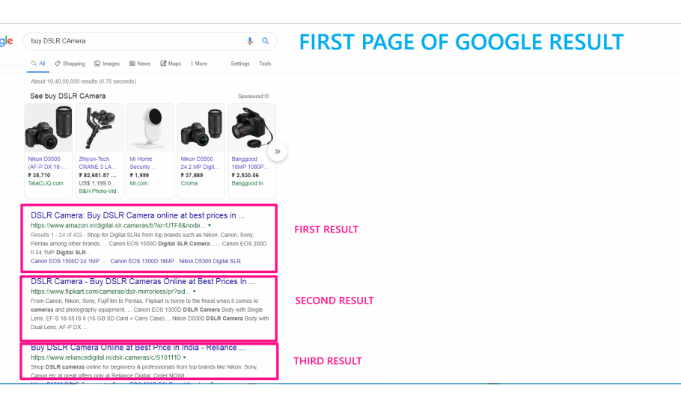

* Inorganic results are usually advertisement and sponsored content. You have to pay to Google to get your advertisements placed here. However, just paying some amount to Google does not guarantee that your ad will be placed.
* Google is not accepting any money at all to place your website on very first page of results.

**How does Google Search Engine work?**

* All WebPages information is organized in the Search Index by Google.
* Google collects information about millions of webpage using Web Crawlers.
* Crawling process begins when a website address is submitted to Google by the website owners through specially design platform by Google for this purpose called ‘Google Search Console.
* 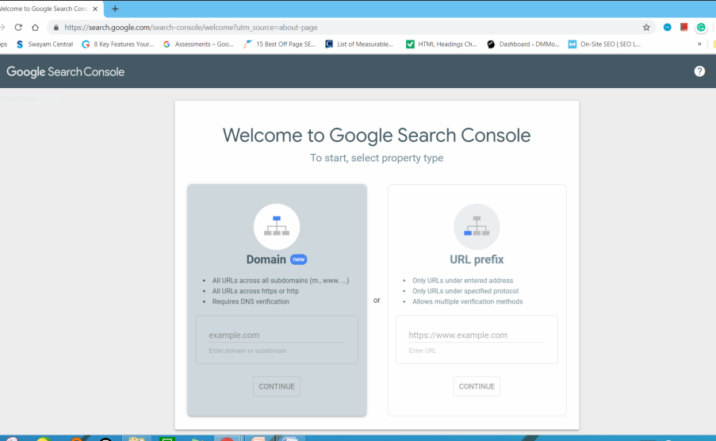
* When crawlers visit websites, they collect relevant information from the home page and follow other links provided on the home page to collect more information about your website and bring data about these pages back to the Google Server .
* 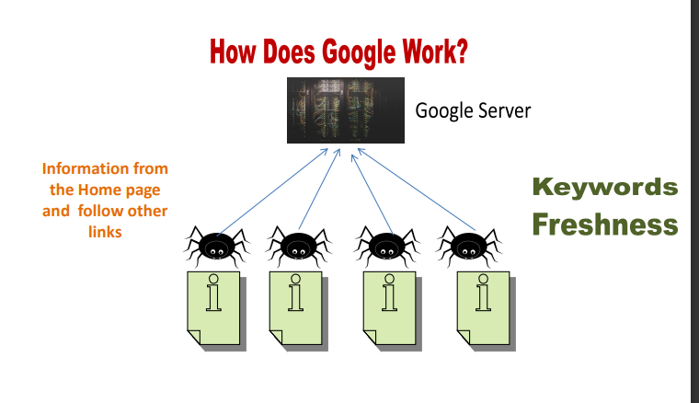
* Google Server is very huge where data of all the websites is stored
* It was all decided by a computer programme which site to crawl, how often and how many pages to fetch from each site

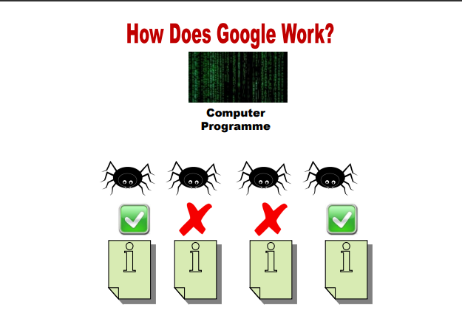

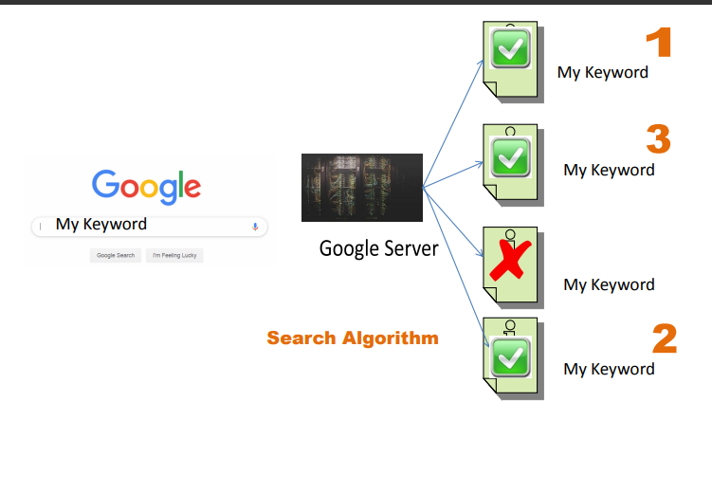

* Key signals of a webpage such as keywords, freshness etc. are recorded for each page in the Search index while crawling the site by crawlers.
* Google Search Index contains hundreds of billions of WebPages Appx 100, million Gigabyte data.
* when it comes to the ranking of the websites, Search algorithms look at many factors, including the words of your query, relevance and usability of pages, quality of WebPages through page rank, the expertise of sources, and your location and settings. Then the weight is assigned to each factor to arrive at the final ranking
* 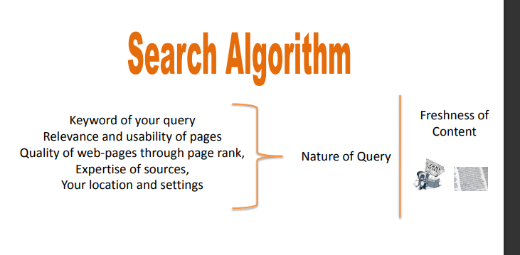
* Once the sorting is done results are sent back to the users in SERP.
* Search Engine Optimization:

Search Engine Optimization is the process of maximizing the number of quality visitors to a website by ensuring the high rank in the list of organic results returned by a search engine.

* Search Engine Optimization is all about organic results, mean what practices, strategies or tactics, we used to get our website ranked high in the organic search results so that maximum visitors can land on my website.
* There are two types of Search Engine Optimization:
* On-Page –SEO
* OFF-Page SEO
* According to MOZ, On-page SEO is the practice of optimizing individual web pages to get them ranked higher and earn more and relevant traffic to your website from the organic results of search engines. Further, it refers to both the content and HTML source code of a page that can be optimized. Example: You would like to insert relevant keywords into your WebPages, that your prospects or customers usually type in the search engine to find your website. It is an example of On-page SEO.
* According to MOZ, Off-page SEO refers to actions taken outside of your own website to impact your rankings within search engine results pages (SERPs).
* Off-page SEO is often called a back-link building process but not restricted to that only. 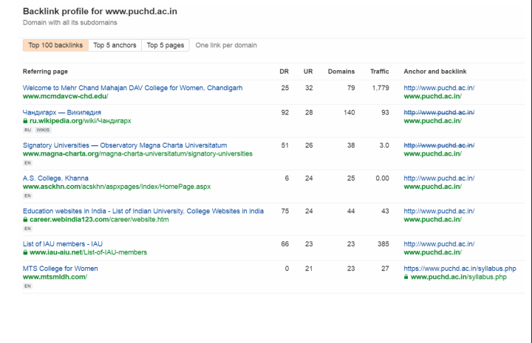

**M -10: Keyword Planner Tools*:***

* 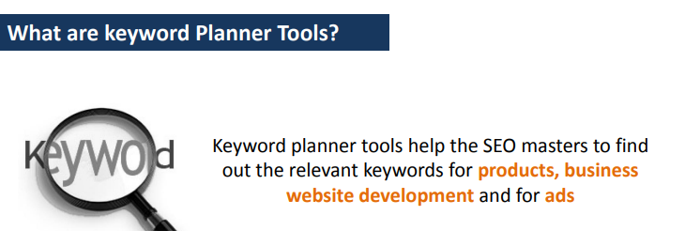
* The word or couple of words entered by you in Keyword planner terminology is called a “SEED KEYWORD”
* These keyword planner tools may help you in finding the relevant keyword for your website and SEO like
* Google Keyword Planner
* Google Trends
* Keyword Shitter
* Google Search Console
* Suggestion Keyword Finder
* Word Tracker Scouts
* And Many More
* 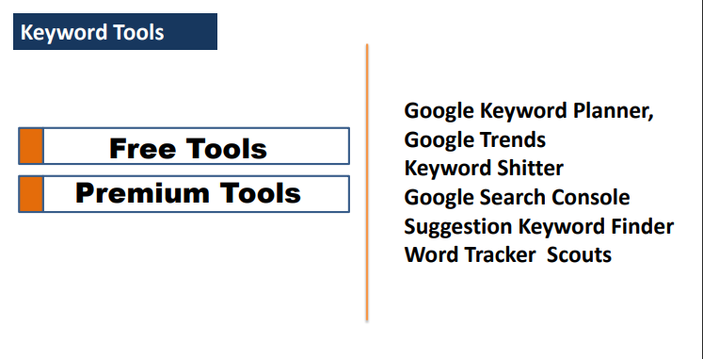
* Google Keyword Planner:
* A Google keyword planner is primarily used for Google Ads.
* However, this tool can also be used to identify various keywords for search engine optimization
* 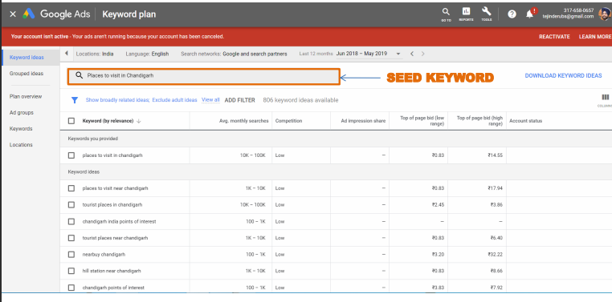
* To use the Google Keyword Planner tool Go to Google and search for Keyword Planner Go the Second, Results “Key Word Planner-Google Ads. As I said, keyword planner is a sub-part of Google Ads and is primarily used to target the keywords for advertisement purpose. However, we are going to use this tool for getting keywords ideas for the purpose of Search Engine Optimization.
* You have to ultimately reach to this page of Google Ads. To access the Keyword Planner, go to tools And under planning, select Keyword Planner -> Here, you have two options

* Discover New Keywords

* Get Search Volume

* forecast

As our purpose is to get new keyword ideas, let us select this one In the pop-up window There are two options Either you can enter URL OR a Keyword about the topic for which you want keyword ideas.

* 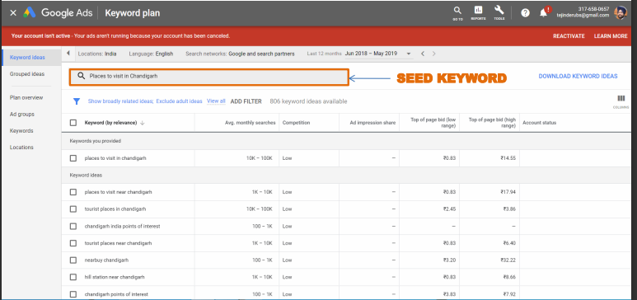
* According to the new feature added by Google, you can also add up to 10 Keywords in one go for which you want keyword ideas.
* Actually being searched by the users in the Google search engine during the period of last one year.
* 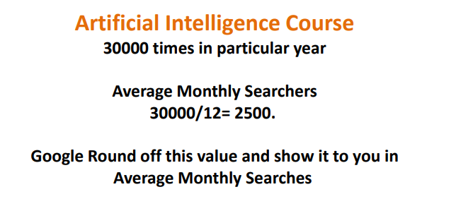
* Search Network
* Google:

If you select only Google, Then this planner will suggest you the keyword ideas based on searches taking place in Google search engine only.

* Google and Search Partners: But this is not the only place where we search; we also search in maps, YouTube, Google Images etc
* you can download the list of keywords in excel file and do some research it.
* You can also get keyword ideas on the basis of URLs as well. This URL may be of your Website or your competitor’s website. Simply, type the URL and select whether you want the ideas on the basis of Entire site, this page only, or as a keyword. Select the entire site and get results. And here is the list of suggested keywords.

********************

* Google Trends:
* 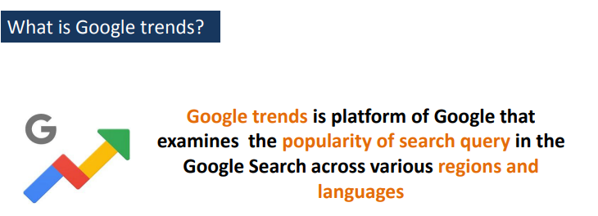 
* 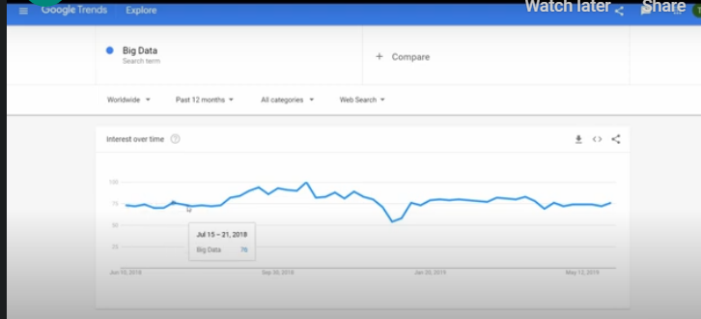
* You can see, there is a trend line which represents the interest over time i.e. popularity which ranges from the scale 0-100. Where100 means maximum interest and 0 means no interest.
* 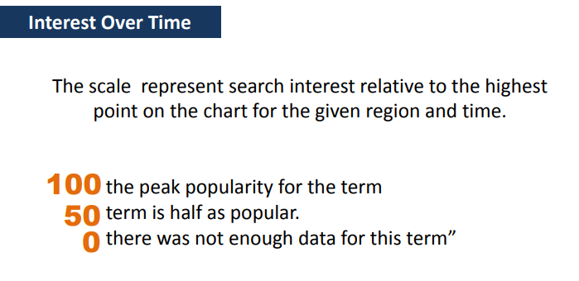
* 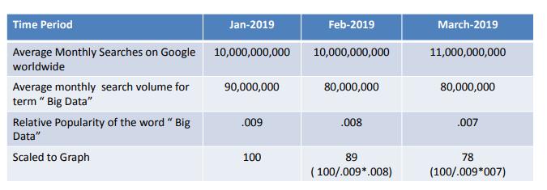 2:45

**********************

* Keyword Shitter (<https://keywordshitter.com/)>)
* 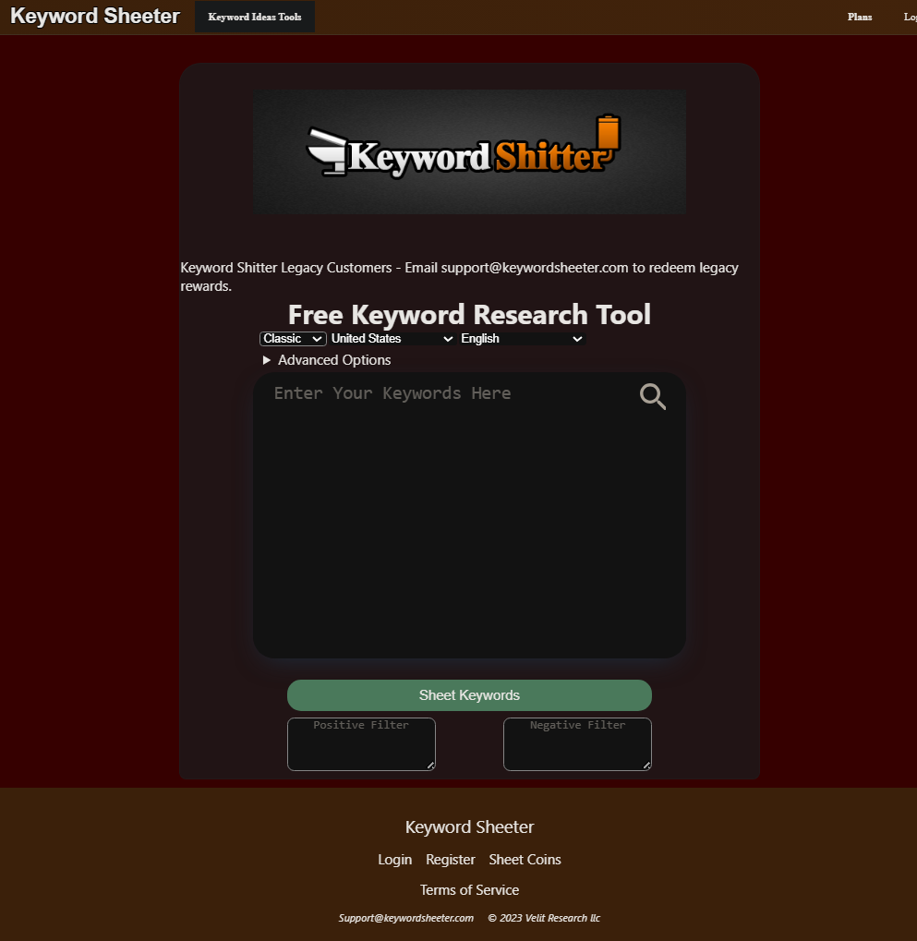
* Keyword Shitter is very simple tool to get keyword ideas in bulk on a seed keyword
* The first word will be your seed word and next few words will be suggested by the tool to make a complete phrase.
* **Suggestion Keyword finder:** (<https://tools.seochat.com/tools/related-keywords-tool>)

Suggestion Keyword Finder is another very simple tool to get ideas about Keywords. It has three levels which help in finding the long phrases

* At level one, it will give you ten best results keywords or sub keywords
* At Level 2, it will pick each phrase or words from level one and suggest 10 more keywords for that phrase.
* **Word tracker Scouts** is a Chrome extension and can be used to find important keywords from competitor’s site to check the relevancy of keywords
* You can also apply various filters to find out the long-tail keywords
* It will present the data in the form of WordCloud where keywords bigger in the font size are more relevant to this page based on Word tracker Scouts’s algorithm.
* The number 54 represent number of keyword at given point

**M -11: On Page SEO Techniques-Indexing and Key Word Placement:**

* 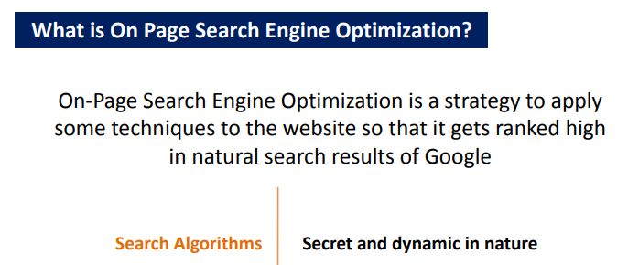
* 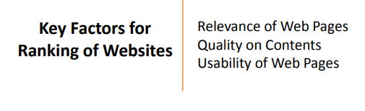
* Comprehensive list of on-page SEO Techniques though not limited to these:

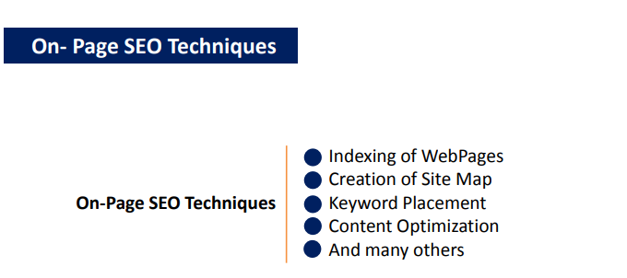

* Your website will not appear on any page of the Google results until it is indexed by Google. Therefore, the very first step in SEO is to submit your site to the search engine, so that crawlers or spiders start visiting your website.
* It is just like a competition, if you want to win the competition, first you have participated in it. Only then, you can think about winning the completion.
* ***How to submit your site to the Google for indexing purpose?***
* Google Search Console is a free tool by Google to Webmasters.
* Primarily, Google Search Console is used for submitting sites to Google for indexing of the website. It also measures the indexing status, optimizes page visibility of the site by fixing various issues.
* The earlier brand of Google, Google Webmaster was rebranded as Google Search Console in May 2015
* We have two methods to submit our domain or site for verification purpose in Google Search Console:
* Domain
* URL prefix

We will use the second one. Your website will be called Property here



* Write the full name of Your site starting with http:// yourdomainname ( with .in/ .com/ .else) I have put the full address of my website, i.e. dmmoc.in. prefixed by http:// It will not accept your site without prefix which may be http or https. Continue
* There are four methods to verify the ownership:
* HTML file and upload it to your site.
* HTML Tag **recommend
* And other methods **are Google Analytics**, **Google Tag Manager** and **Domain Name Provider.**
* Just copy the code. Please Don’t click on verify. We will come back to it shortly Go to the WordPress dashboard of your site and install Plug-in AMS Google Webmaster tools by searching Google webmaster.
* Go back to the Google Search Console and click verify. It will take a few moments. Congratulations!! Your ownership has been verified with HTML tag
* The next important step in the site indexing is to submit the sitemap to Google Search Console
* **What is a Sitemap?** A sitemap in the context of SEO is often referred to XML Site Map. In simple terms, it is a list of web pages in your website to submit to the Google or other search engines to give an idea about how the content of a site is organized.
* Search Engine Spiders or Crawlers read this map or file to crawl your site for the collection of relevant information.
* 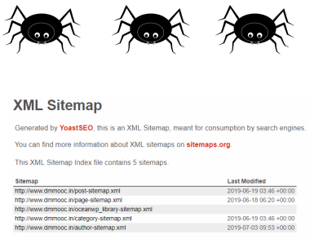
* 
* There are many third-party online platforms available to create XML sitemap.
* I will use one WordPress Plug-in here. Search for Google XML Sitemap The very first Plug-in is Google XML Sitemap.

**************************

* **The second technique of On-Page SEO is Keyword Placement**
* 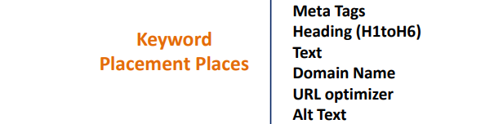
* 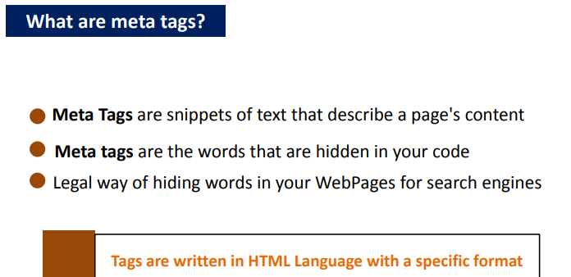
* 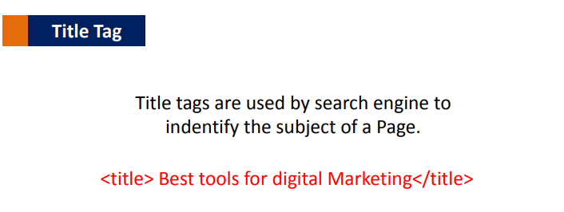
* 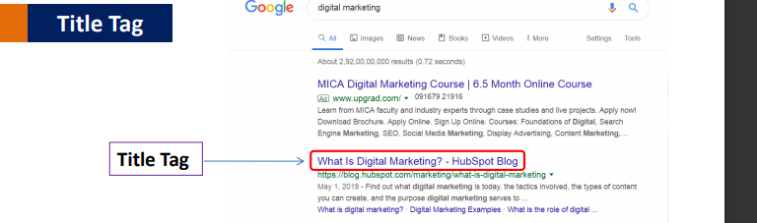
* 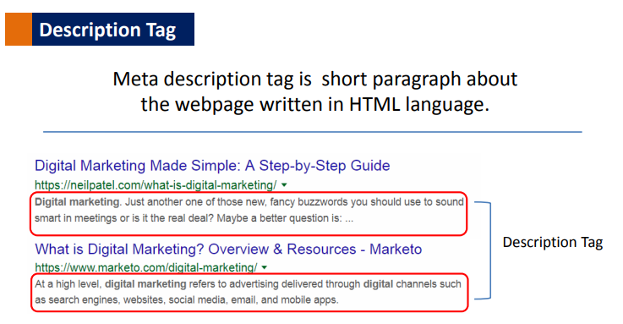
* 
* 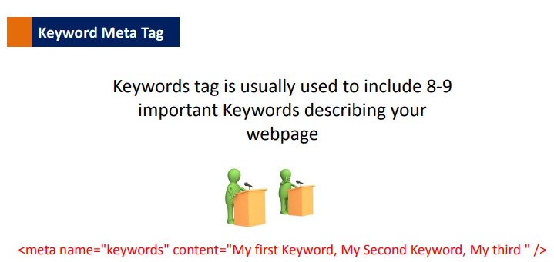

***************************

* There are six levels of Heading in HTML. H1 being the Highest Level and H6 is the lowest level.
* 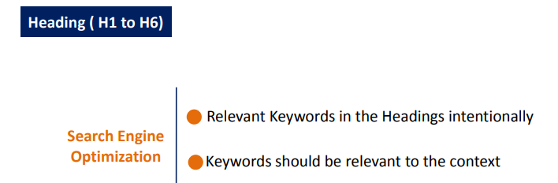
* 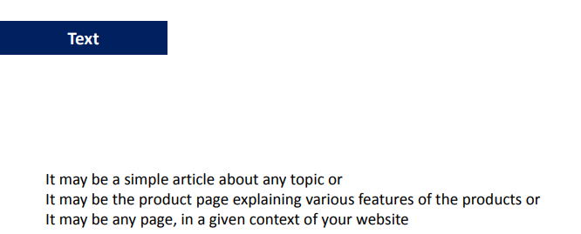
* 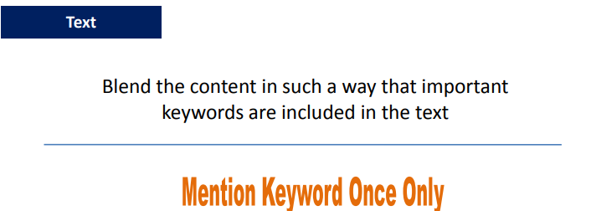
* 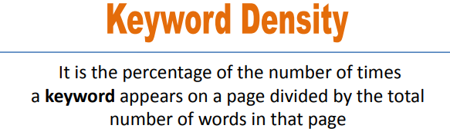
* The name of this small but effective tool is Keyword Density Checker and is available on this URL (https://www.seoreviewtools.com/keyword-density-checker/)
* 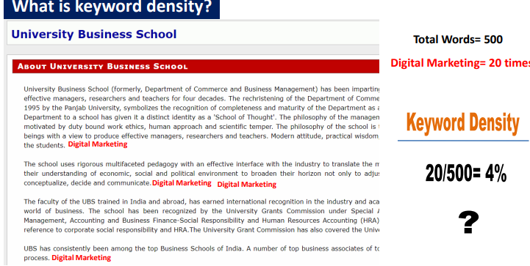
* Google has the policy to penalize the keyword stuffing and treating your content as spam. Therefore, when you develop the content, be natural. Don’t unnecessary try to repeat the keywords in your content

************************

* 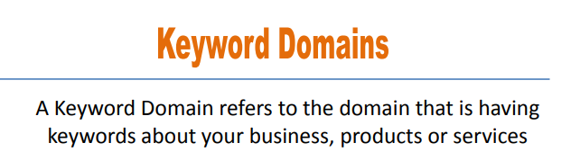
* URL stands for Uniform Resource Locator and is the address of your webpage.
* **URL Optimizer:**
* Go to WordPress Dashboard From Settings, go to, Permalink ->Go to all posts Select edit the post in which you want to add a few more keywords. Go the Document setting of that page and them permalinks In URL slug, you can add any word you want Like ‘social media marketing’ with a hyphen (-) in each word And also notice, in the ULR preview, it has been added
* 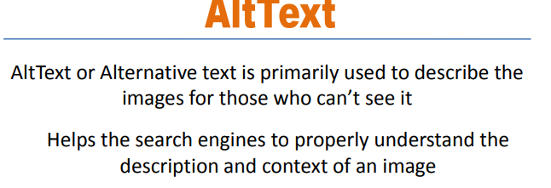

***Week 5:***

**M -12: On Page SEO Techniques- Content Optimization*:***

* **Content Optimization** is a part of overall Search Engine Optimization process where content of WebPages is optimized to make the content more relevant, attractive and actionable for the audience
* 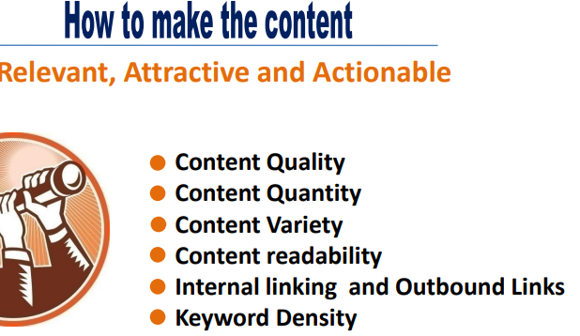
* 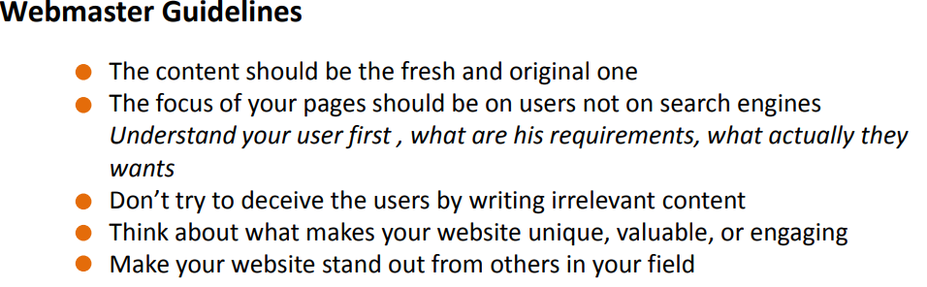
* 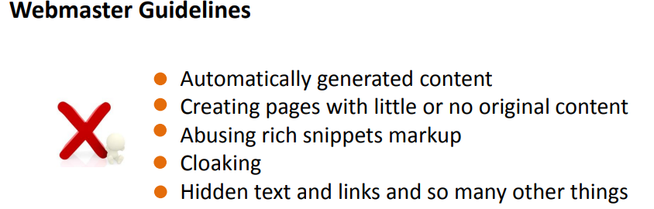
* 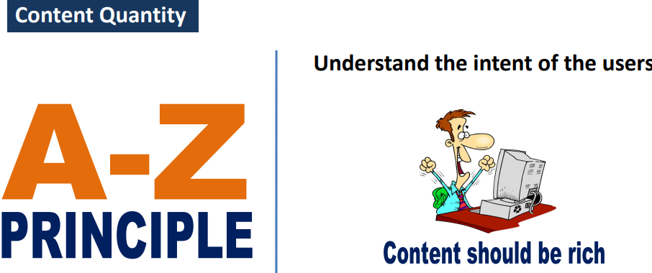
* 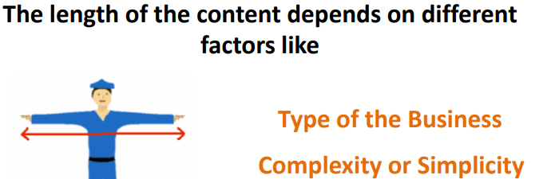

***********************************************

* 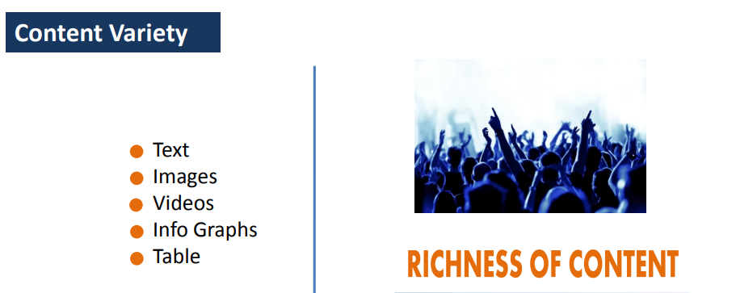
* 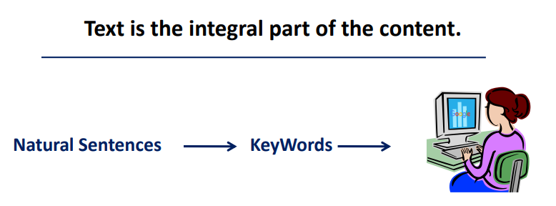
* 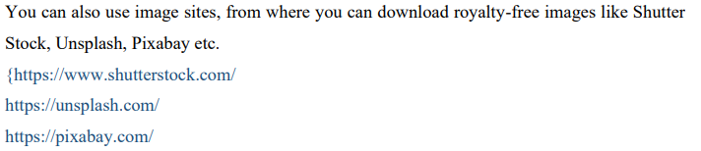
* s. It is always advised that video should be hosted on a trusted platform first and then embed it in the content. There are many such platforms where a video can be hosted Like: Youtube, Vimeo, Dailymotion, Veoh
* 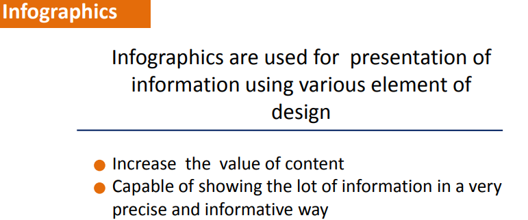
* You can also use online tools to design infographics such as Canva, Visme, easel.ly, Visualizeme
* 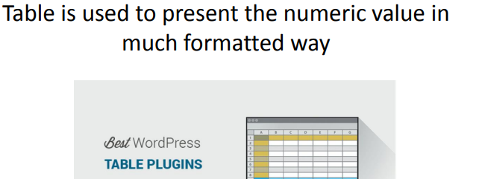
* **Content readability** search engines don’t calculate readability score, however, they measure the human behaviour on a page. Therefore, it is important to improve the human behaviour on-page by increasing the content readability
* There are many techniques for improving content readability:
* Top font for web designing. THESE WEB SITE ARE :www.flyinghippo.com, https://www.websitebuilderexpert.com, https://www.typewolf.com
* The ideal font size for web browsing is 16 pix.
* There is a simple rule that the line height should be 150% of the font size. Suppose, we are using 14px font then the line height should be 21px.
* The good number of words in a line would be 9-12 words or between 50-60 characters
* You may install few plug-ins for typography in the WordPress like Google Fonts Typography Google Typography Easy Typography etc. but in most of the plug-ins you will not be able to see the live preview of the change.
* But there is, one plug-in Elementor where you will be able to see the live preview of your fontrelated settings .This is the Elementor interface

********************************************************

* ***Internal and Outbound linking:***
* **Internal linking** refers to linking any word, image, video or page to any other element within the website by putting hyperlinking. It makes the site more user-friendly and offers good navigation. An effective hyperlinking is always considered as good from an SEO point of view
* **Outbound linking** is similar to internal linking with a difference that the target page is the any another page on the web except page of your website
* **Keyword Density**:
* The name of this extension is SEO Quake, one of the favourite tool of SEO masters.

**M -13: On Page SEO : Yoast SEO Plug-in:**

* 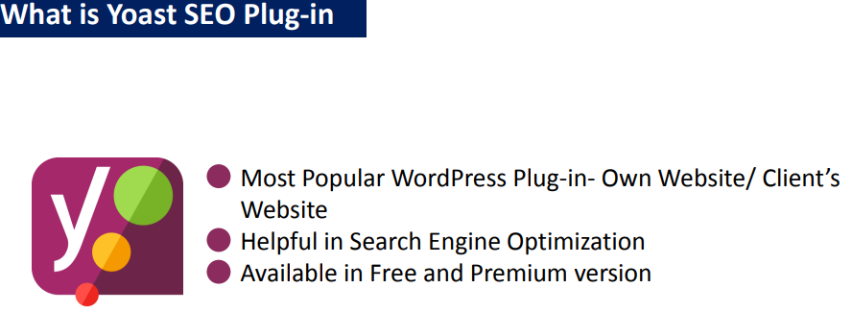
* Having both Yoast SEO Plug-in and xml-side map may create problem, so deactivate xml-side
* Date of snappiest preview means how latest the post is.

**M -14: Off Page SEO Techniques:**

Off-page SEO refers to techniques that can be used to improve the position of a web site in the Search Engine Results Page (SERPs) by using some techniques outside the web pages

* 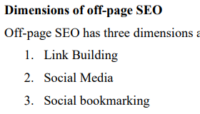
* Basically, by building external links to your website, you are trying to gather as many ‘votes’ as you can in favour of your website so that you can bypass your competitors and rank higher in the SERP.
* 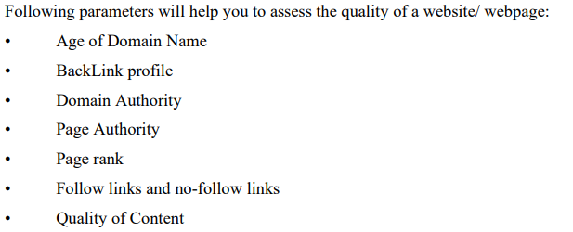
* how to check Age of any domain with other details Go to https://smallseotools.com/domain-age-checker/ .
* Back Link profile A backlink refers to a link; a website gets from another website. It is just an external link.
* 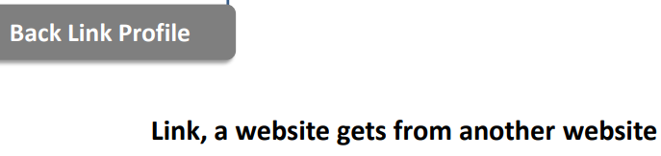

***************************************

* **Domain Authority** is a search engine ranking score developed by Moz. The score of domain authority predicts how well a website will rank on search engine result pages (SERPs) The DA score ranges from 1-100, where greater score corresponding to a greater ability to be ranked **.**
* Websites like Google, Youtube, Facebook is having very high domain Authority may be more than 90.
* how to check domain authority 1. Go to Chrome Webstore 2. Search for MOZ bar extension 3. The first result is MOZ bar 4. Click Add to Chrome 5. Extension is adde
* 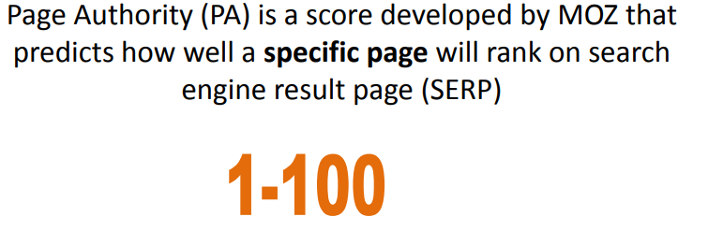
* 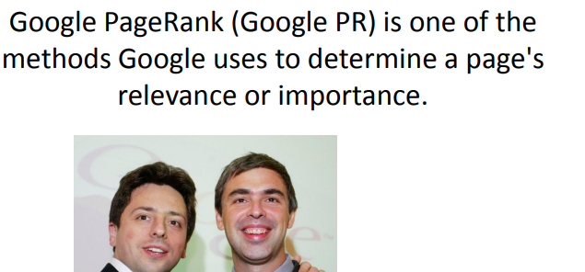
* Google PageRank (Google PR) was invented by Google Founder Larry Page and Sergey Brin.
* 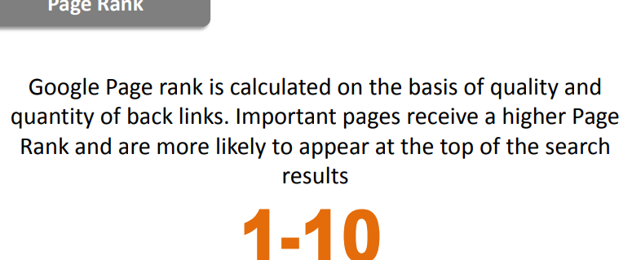
* 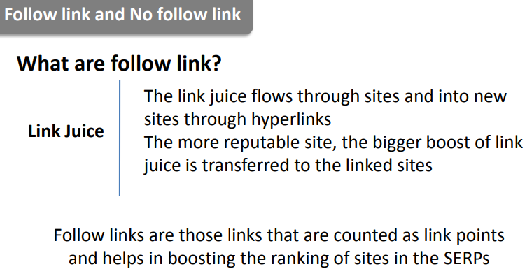
* Therefore, it is very clear ‘No-follow links’ will not help in SEO and efforts should be made to secure follow links only. The concept of ‘no-follow link’ was introduced to avoid the spamming of links.
* 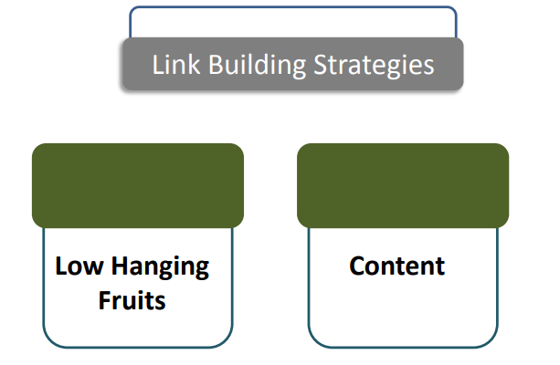
* 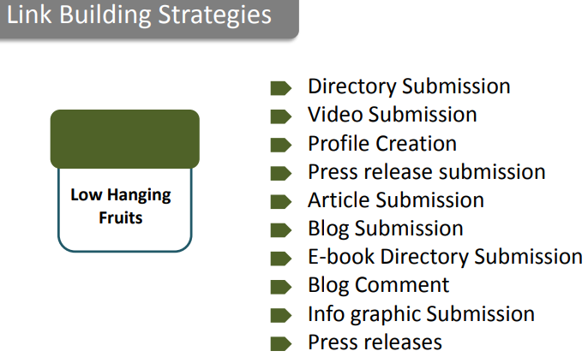
* Submission of your site to web directories increases web presence and eventually earn the link for your website. Example: There are many web directories available online for site submission like IndiaMart, India Biz List, Dmoz, Zoom Info, Best of web, PR web directory
* Don’t forget to give a link of your website in the description section of video . like you YouTube, Vimeo, DailyMotion and many other websites
* Article Submission /Writing ->
* There are many good sites where you can submit articles like Ezinearticles.com, e-how, articlecity.com ,hubpages.com article cube
* Blog Submission:
* You may get few backlinks from these sites through your posts.like https://www.tumblr.com/
* <https://www.blogger.com>
* <https://medium.com>
* http://www.soup.io/
* Top e-book submission sites are; www.getfreeebooks.com ps://www.smashwords.com https://www.kobo.com/in/en/p/writinglife https://www.freebooksy.com/editorial-submissions/ <https://www.ebookstage.com>
* You can also use online tools to design infographics such as Canva, Vismeeasel.ly, Visualize me.
* Press releases are ways of announcing events, products launch, news about business etc to the press.
* There are many free sites to host your press release like http://www.freepressrelease.com/ https://clickpress.com/releases/index.shtml https://www.prlog.org/ More detail <https://www.ereleases.com/pr-fuel/free-press-release-distribution>

**********************************

* There are many sites available for social bookmarking like StumbleUpon, Dribble, Digg, Pocket, Reddit.
* D
* D
* D
* D
* D
* D
* D
* D
* D
* D
* D
* D
* D
* D
* D
* D
* D
* D
* D
* D
* D
* D

D

D

D